temi GO (Kajima - The GEAR Cafe)

Standard Operating Procedure

Contents

**One-Time daily set up** (To be done every operational morning) 2

**Making a Delivery** 4

**Temi Rescue procedure** 5

If temi is on first floor 5

If temi is on Second or Third floor 6

**Troubleshooting Guide** 7

temiGO Not Turned On 7

To turn On 7

To turn Off 7

Wifi Not Connected 7

Connecting to wi-fi 7

temi GO is not speaking (only plays a beep sound) 7

temi GO is not moving (after pressing start delivery) 8

temi GO goes to the wrong place / sequence cannot be played 9

Emergency Stop 9

Delivery application 9

Link to Delivery App user guide: 9

Important Specs 9

Points of Contact 10

# **One-Time daily set up** (To be done every operational morning)

1. Turn on temiGO.
2. This prompt (attached pictured) will appear upon start up,
   1. Click the checkbox to always open USB2Serial
   2. Click on “ok” (this activates temiGO’s weight sensors and colors)

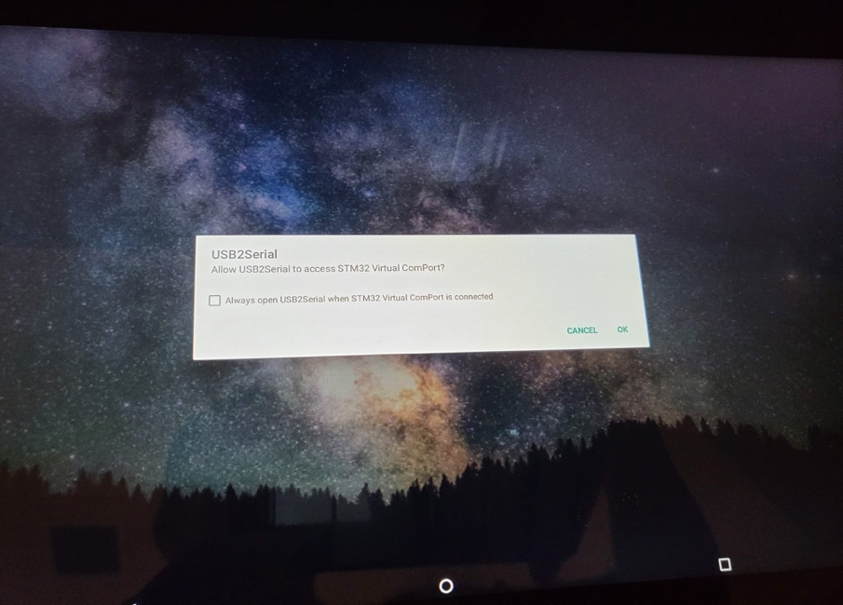

1. Press the Send to Kitchen 1/2 button to send temiGO to standby location by the café.
2. Upon arrival at Kitchen1/2, press the Salvator Core Application. When app launches, status should be “stopped”, if it is running, press stop. Press Start, the app should close and a small pop up will appear saying “Core Ready”.
3. Open the Delivery app by pressing the button on the home page.
4. Press the settings icon in the delivery application (no password currently, press enter)
   1. Press on settings in the left column.
   2. Check the following:
      1. Home location (standby location: kitchen1 for temiGO1, kitchen2 for temiGO2)
      2. Timeout at destination (recommended 3 mins)
      3. Tare weight (Make sure tray is loaded with the empty food and drink trays … but not loaded with food/drink items before pressing)
      4. LCD text (optional – default is pre-programed: temiGO 1 or temiGO 2)
      5. Color picker (optional - default already pre-programed)

**Note:**

1. All deliveries and movements involving lift/autodoor/turnstile must be done through the delivery application. The “Go Home” button in the main page and “Go to Kitchen 2” button should not be used if temi GO has to go through turnstile, auto door or lifts on the way to the location.

# **Making a Delivery**

1. After doing the one time daily set up above, the delivery application will be ready for use throughout the whole day.
2. Press on the delivery locations (up to 3 locations)
   1. If there are any mis-clicks, option can be removed by pressing the corresponding location on the Selected Locations column on the right.
3. Load the trays (tray 1 for location 1, tray 2 for location 2, tray 3 for location 3)
   1. **Note**: you can load more than one tray for a location, however, when temiGO senses that the tray for that location has been emptied, temiGO will proceed to the next step (unless manually stopped by user)
4. Once trays have been loaded, press on start delivery.
5. Temi GO will deliver to all assigned locations and return to its standby location (Kitchen 1 for temiGO 1 or Kitchen 2 for temiGO 2), ready for next delivery.

# 

# **temiGO Rescue procedure**

1. Click the button (nine squares) on top right corner, swipe left and click on settings button, click on map editor

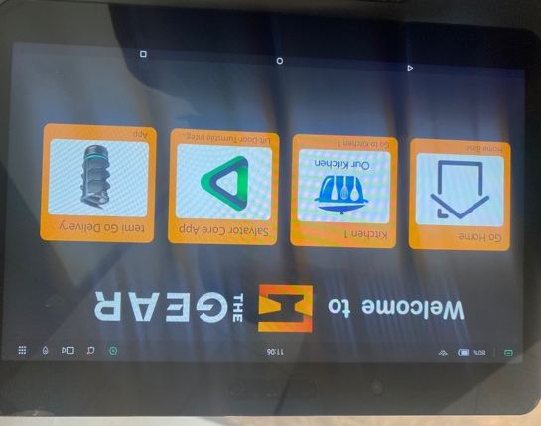

1. Check the floor temiGO is on (indicated by the green rectangle) , if temi has the wrong floor map loaded, load the correct floor by pressing the three vertical button on right of floor, followed by load floor

# Next Steps:

# If temiGO is on first floor

1. Press the red emergency button and push temiGO back to home base
   1. (Remember to unlock when you have reached the home base)
2. Press the small square on right side of the bottom navigation bar
3. Swipe upward to kill application
4. Kill the robot core and delivery application
5. Open robot core application, press stop, then start
6. Open delivery application, temiGO is ready for use again

# If temiGO is on Second or Third floor

1. Make sure there are no autodoors or lifts nearby (at least 2m away), if there is, push temiGO to another area (recommended location lvl 2 and lvl 3 pantry)
2. Open up the map editor page, press map options and press auto repositioning

1. Press the small square on right side of the bottom navigation bar
2. Swipe upwards to kill application
3. Kill robot core and delivery application
4. Open robot core application, press stop and start
5. Open Delivery Application, do not open the settings page, send temiGO back to kitchen ½ by clicking kitchen 1 / 2 and then start delivery

# **Troubleshooting Guide**

# temiGO Not Turned On

## To turn On

1. Press the button located under base of the platform. (temiGO trays and screen will light up)

## To turn Off

1. Press the button located under base of the platform.
2. Press shut down button on temiGO screen.

# Wifi Not Connected

# Connecting to wi-fi

1. Click the wifi icon on the top navigation bar.
2. Connect to TGR – IOT (autosaved)
3. Once connected, wifi symbol will display on top navigation bar

# temi GO is not speaking (only plays a beep sound)

1. Check Wifi connection status on left corner of top bar
2. If WIFI is not connected, please follow connecting to wifi guide above.
3. At times, when wifi connection is weak, verbal message may not play.

# temi GO is not moving (after pressing start delivery)

1. Check that the Red Emergency Stop button (as shown in the picture below) located behind temi GO is not accidentally pressed. Twist the Stop button clockwise to release the stop button. If temiGO is still unable to move, proceed to step 2

1. Close the delivery application (press the bottom right button on bottom navigation bar and swipe up until no apps remain)
2. Check the map status
   1. Top navigation bar most right button (nine dots)
   2. Swipe left until you see settings button
   3. Click on map editor
   4. Click the 3 vertical button next to Fl 01, and press ‘load floor’ (this is to set the map on temiGO to floor 1 map, where the base base is situated.
   5. Press the emergency stop button and push temi back to home base (located at first floor behind the Cafe). On reaching home base, twist emergency stop button clockwise.
      1. Note: if prompted whether home base has been shifted, click ‘No’

1. Open the Salvator Robot Core app.
2. Press stop, wait a few seconds, then press start. (The application will close and a notification saying Core ready will be shown briefly)
3. Press the delivery application button to open the application.

# temi GO goes to the wrong place / sequence cannot be played

1. Refer to Above: temiGO is not moving (Step 3 onwards)

# Emergency Stop

1. In the event of an emergency, please press the red button as shown in the picture. This button stops temiGO from moving on its own and allows temiGO to be pushed manually. It may take a couple of seconds for the wheels to be released.

1. After the emergency stop has been pressed, temiGO must be restored manually by twisting the red button clockwise to continue operation.

# Delivery application

1. The delivery application has been preset with agreed values/ pictures when we visited The GEAR to set up temiGO.
2. If you would like to change certain stuff or the looks, please take a look at the following link for the user guide to the Delivery Application to see what is customizable.

# Link to Delivery App user guide:

<https://github.com/temideveloper/Rs-App-Guides/tree/master/TemiGo-Delivery(TLA%20integration)>

# 

# Important Specs

1. Weight limits (top tray – 8kg , middle tray – 10kg , bottom tray – 12kg)

# 

# Points of Contact

1. temiGO Gear Café whatsapp chat group
2. Mr Lim Wen Chyi – 8303 2264 (Whatsapp – Robosolutions)